***University Physics Volume I***

**Unit 1: Mechanics**

**Chapter 2: Vectors**

**Conceptual Questions**

1. A weather forecast states the temperature is predicted to be  the following day. Is this temperature a vector or a scalar quantity? Explain.

Solution

scalar

1. Which of the following is a vector: a person’s height, the altitude on Mt. Everest, the velocity of a fly, the age of Earth, the boiling point of water, the cost of a book, Earth’s population, or the acceleration of gravity?

Solution

velocity of a fly, acceleration of gravity

1. Give a specific example of a vector, stating its magnitude, units, and direction.

Solution

answers may vary

1. What do vectors and scalars have in common? How do they differ?

Solution

answers may vary

1. Suppose you add two vectors  and What relative direction between them produces the resultant with the greatest magnitude? What is the maximum magnitude? What relative direction between them produces the resultant with the smallest magnitude? What is the minimum magnitude?

Solution

parallel, sum of magnitudes, antiparallel, zero

1. Is it possible to add a scalar quantity to a vector quantity?

Solution

no

1. Is it possible for two vectors of different magnitudes to add to zero? Is it possible for three vectors of different magnitudes to add to zero? Explain.

Solution

no, yes

1. Does the odometer in an automobile indicate a scalar or a vector quantity?

Solution

scalar

1. When a 10,000-m runner competing on a 400-m track crosses the finish line, what is the runner’s net displacement? Can this displacement be zero? Explain.

Solution

zero, yes

1. A vector has zero magnitude. Is it necessary to specify its direction? Explain.

Solution

no

1. Can a magnitude of a vector be negative?

Solution

no

1. Can the magnitude of a particle’s displacement be greater that the distance traveled?

Solution

no

1. If two vectors are equal, what can you say about their components? What can you say about their magnitudes? What can you say about their directions?

Solution

equal, equal, the same

1. If three vectors sum up to zero, what geometric condition do they satisfy?

Solution

they form the sides of a triangle

1. Give an example of a nonzero vector that has a component of zero.

Solution

a unit vector of the *x*-axis

1. Explain why a vector cannot have a component greater than its own magnitude.

Solution

The length of a vector component is a side of a right triangle, where the hypotenuse is its magnitude.

1. If two vectors are equal, what can you say about their components?

Solution

They are equal.

1. If vectors and  are orthogonal, what is the component of  along the direction of  What is the component of  along the direction of 

Solution

zero, zero

1. If one of the two components of a vector is not zero, can the magnitude of the other vector component of this vector be zero?

Solution

yes

1. If two vectors have the same magnitude, do their components have to be the same?

Solution

no

1. What is wrong with the following expressions? How can you correct them? (a)  (b)  (c)  (d)  (e)  (f)  (g)  (h ) (i)  and (j)

Solution

a. , b.  or , c. , d. , e. , f.  g. left side is a scalar and right side is a vector, h. , i. , j. 

1. If the cross product of two vectors vanishes, what can you say about their directions?

Solution

They are parallel.

1. If the dot product of two vectors vanishes, what can you say about their directions?

Solution

They are orthogonal.

1. What is the dot product of a vector with the cross product that this vector has with another vector?

Solution

zero

**Problems**

1. A scuba diver makes a slow descent into the depths of the ocean. His vertical position with respect to a boat on the surface changes several times. He makes the first stop 9.0 m from the boat but has a problem with equalizing the pressure, so he ascends 3.0 m and then continues descending for another 12.0 m to the second stop. From there, he ascends 4 m and then descends for 18.0 m, ascends again for 7 m and descends again for 24.0 m, where he makes a stop, waiting for his buddy. Assuming the positive direction up to the surface, express his net vertical displacement vector in terms of the unit vector. What is his distance to the boat?

Solution

, 49 m

1. In a tug-of-war game on one campus, 15 students pull on a rope at both ends in an effort to displace the central knot to one side or the other. Two students pull with force 196 N each to the right, four students pull with force 98 N each to the left, five students pull with force 62 N each to the left, three students pull with force 150 N each to the right, and one student pulls with force 250 N to the left. Assuming the positive direction to the right, express the net pull on the knot in terms of the unit vector. How big is the net pull on the knot? In what direction?

Solution

, 110 N, to the left

1. Suppose you walk 18.0 m straight west and then 25.0 m straight north. How far are you from your starting point and what is the compass direction of a line connecting your starting point to your final position? Use a graphical method.

Solution

30.8 m,  west of north

1. For the vectors given in the following figure, use a graphical method to find the following resultants: (a)  (b)  (c)  (d)  (e)  (f)  (g) ; and (h) 

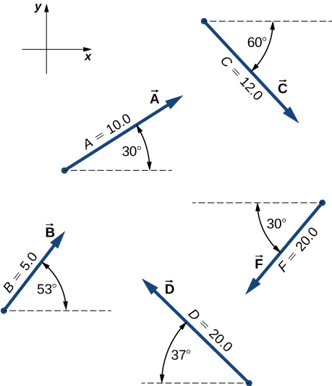

Solution

a. 14.73,; b. 11.05,; c. 33.35, ; d. 5.74,; e. 22.08, ; f. 30.00, ; g. 65.97, ; h. 73.66, 

1. A delivery man starts at the post office, drives 40 km north, then 20 km west, then 60 km northeast, and finally 50 km north to stop for lunch. Use a graphical method to find his net displacement vector.

Solution

134 km, 

1. An adventurous dog strays from home, runs three blocks east, two blocks north, one block east, one block north, and two blocks west. Assuming that each block is about 100 m, how far from home and in what direction is the dog? Use a graphical method.

Solution

360 m, 

1. In an attempt to escape a desert island, a castaway builds a raft and sets out to sea. The wind shifts a great deal during the day and he is blown along the following directions: 2.50 km and  north of west, then 4.70 km and south of east, then 1.30 km and  south of west, then 5.10 km straight east, then 1.70 km and  east of north, then 7.20 km and  south of west, and finally 2.80 km and  north of east. Use a graphical method to find the castaway’s final position relative to the island.

Solution

7.34 km,  south of east

1. A small plane flies 40.0 km in a direction  north of east and then flies 30.0 km in a direction  north of east. Use a graphical method to find the total distance the plane covers from the starting point and the direction of the path to the final position.

Solution

64.8 km,  north of east

1. A trapper walks a 5.0-km straight-line distance from his cabin to the lake, as shown in the following figure. Use a graphical method (the parallelogram rule) to determine the trapper’s displacement directly to the east and displacement directly to the north that sum up to his resultant displacement vector. If the trapper walked only in directions east and north, zigzagging his way to the lake, how many kilometers would he have to walk to get to the lake?

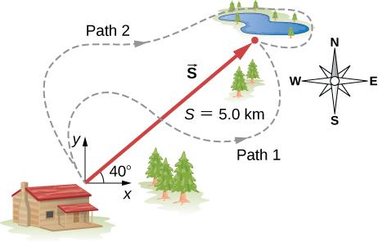

Solution

3.8 km east, 3.2 km north, 7.0 km

1. A surveyor measures the distance across a river that flows straight north by the following method. Starting directly across from a tree on the opposite bank, the surveyor walks 100 m along the river to establish a baseline. She then sights across to the tree and reads that the angle from the baseline to the tree is . How wide is the river?

Solution

70 m

1. A pedestrian walks 6.0 km east and then 13.0 km north. Use a graphical method to find the pedestrian’s resultant displacement and geographic direction.

Solution

14.3 km, 

1. The magnitudes of two displacement vectors are *A* = 20 m and *B* = 6 m. What are the largest and the smallest values of the magnitude of the resultant 

Solution

26 m, 14 m

1. Assuming the +*x*-axis is horizontal and points to the right, resolve the vectors given in the following figure to their scalar components and express them in vector component form.



Solution

a. , b. , c. , d. , f. 

1. Suppose you walk 18.0 m straight west and then 25.0 m straight north. How far are you from your starting point? What is your displacement vector? What is the direction of your displacement? Assume the +*x*-axis is to the east.

Solution

30.8 m, , from the east

1. You drive 7.50 km in a straight line in a direction  east of north. (a) Find the distances you would have to drive straight east and then straight north to arrive at the same point. (b) Show that you still arrive at the same point if the east and north legs are reversed in order. Assume the +*x*-axis is to the east.

Solution

a. 1.94 km, 7.24 km; b. proof

1. A sledge is being pulled by two horses on a flat terrain. The net force on the sledge can be expressed in the Cartesian coordinate system as vector  where  and  denote directions to the east and north, respectively. Find the magnitude and direction of the pull.

Solution

8724.7 N,  north of west

1. A trapper walks a 5.0-km straight-line distance from her cabin to the lake, as shown in the following figure. Determine the east and north components of her displacement vector. How many more kilometers would she have to walk if she walked along the component displacements? What is her displacement vector?



Solution

3.8 km east, 3.2 km north, 2.0 km, 

1. The polar coordinates of a point are  and 5.50 m. What are its Cartesian coordinates?

Solution

(–2.75 m, –4.76 m)

1. Two points in a plane have polar coordinates  and  Determine their Cartesian coordinates and the distance between them in the Cartesian coordinate system. Round the distance to a nearest centimeter.

Solution

, , 6.09 m

1. A chameleon is resting quietly on a lanai screen, waiting for an insect to come by. Assume the origin of a Cartesian coordinate system at the lower left-hand corner of the screen and the horizontal direction to the right as the +*x*-direction. If its coordinates are (2.000 m, 1.000 m), (a) how far is it from the corner of the screen? (b) What is its location in polar coordinates?

Solution

a. , b. 

1. Two points in the Cartesian plane are *A*(2.00 m, –4.00 m) and *B*(–3.00 m, 3.00 m). Find the distance between them and their polar coordinates.

Solution

8.60 m, , 

1. A fly enters through an open window and zooms around the room. In a Cartesian coordinate system with three axes along three edges of the room, the fly changes its position from point *b*(4.0 m, 1.5 m, 2.5 m) to point *e*(1.0 m, 4.5 m, 0.5 m). Find the scalar components of the fly’s displacement vector and express its displacement vector in vector component form. What is its magnitude?

Solution

 *D* = 4.7 m

1. For vectors  and  calculate (a)  and its magnitude and direction angle, and (b)  and its magnitude and direction angle.

Solution

a.  ; b. , 

1. A particle undergoes three consecutive displacements given by vectors   and  (a) Find the resultant displacement vector of the particle. (b) What is the magnitude of the resultant displacement? (c) If all displacements were along one line, how far would the particle travel?

Solution

a. , b. , (c) 

1. Given two displacement vectors  and  find the displacements and their magnitudes for (a)  and (b) 

Solution

a. ;

b. 

1. A small plane flies  in a direction  north of east and then flies  in a direction  north of east. Use the analytical method to find the total distance the plane covers from the starting point, and the geographic direction of its displacement vector. What is its displacement vector?

Solution

64.8 km and 40.9º north of east,  and is to the east

1. In an attempt to escape a desert island, a castaway builds a raft and sets out to sea. The wind shifts a great deal during the day, and she is blown along the following straight lines: 2.50 km and  north of west, then 4.70 km and  south of east, then 1.30 km and south of west, then 5.10 km due east, then 1.70 km and  east of north, then 7.20 km and  south of west, and finally 2.80 km and  north of east. Use the analytical method to find the resultant vector of all her displacement vectors. What is its magnitude and direction?

Solution

 is to the east, 7.34 km, 

1. Assuming the +*x*-axis is horizontal to the right for the vectors given in the following figure, use the analytical method to find the following resultants: (a)  (b)  (c)  (d)  (e)  (f)  (g)  and (h) 

Solution

a. , b. , c. , d. , e. , f. , g. , h. 

1. Given the vectors in the preceding figure, find vector  that solves equations (a)  and (b)  Assume the +*x*-axis is horizontal to the right.



Solution

a. , b. 

1. A delivery man starts at the post office, drives 40 km north, then 20 km west, then 60 km northeast, and finally 50 km north to stop for lunch. Use the analytical method to determine the following: (a) Find his net displacement vector. (b) How far is the restaurant from the post office? (c) If he returns directly from the restaurant to the post office, what is his displacement vector on the return trip? (d) What is his compass heading on the return trip? Assume the +*x*-axis is to the east.

Solution

a. , b. *R* = 134.32 mi, c. , d.  south of west

1. An adventurous dog strays from home, runs three blocks east, two blocks north, and one block east, one block north, and two blocks west. Assuming that each block is about a 100 yd, use the analytical method to find the dog’s net displacement vector, its magnitude, and its direction. Assume the +*x*-axis is to the east. How would your answer be affected if each block was about 100 m?

Solution

 *D* = 360.5 yd,  north of east; The numerical answers would stay the same but the physical unit would be meters. The physical meaning and distances would be about the same because 1 yd is comparable with 1 m.

1. If   and  find the unknown constants *a* and *b* such that 

Solution

*a* = 5, *b* = 7

1. Given the displacement vector  find the displacement vector  so that 

Solution



1. Find the unit vector of direction for the following vector quantities: (a) Force  (b) displacement  and (c) velocity 

Solution

a. , b. , c. 

1. At one point in space, the direction of the electric field vector is given in the Cartesian system by the unit vector  If the magnitude of the electric field vector is *E* = 400.0 V/m, what are the scalar components   and  of the electric field vector  at this point? What is the direction angle  of the electric field vector at this point?

Solution

    

1. A barge is pulled by the two tugboats shown in the following figure. One tugboat pulls on the barge with a force of magnitude 4000 units of force at  above the line AB (see the figure and the other tugboat pulls on the barge with a force of magnitude 5000 units of force at  below the line AB. Resolve the pulling forces to their scalar components and find the components of the resultant force pulling on the barge. What is the magnitude of the resultant pull? What is its direction relative to the line AB?

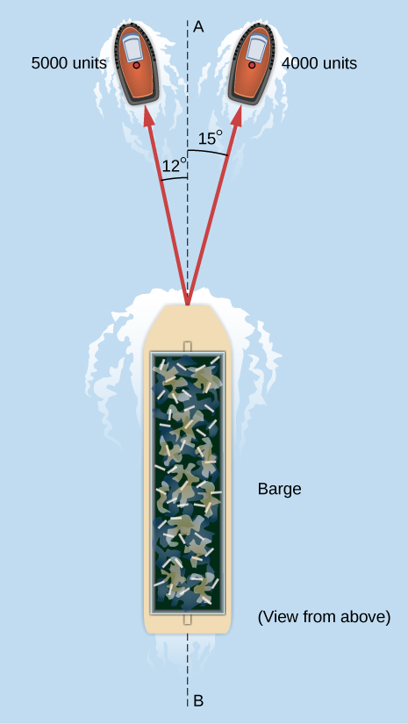

Solution

8754 units of force, approximately along AB

1. In the control tower at a regional airport, an air traffic controller monitors two aircraft as their positions change with respect to the control tower. One plane is a cargo carrier Boeing 747 and the other plane is a Douglas DC-3. The Boeing is at an altitude of 2500 m, climbing at  above the horizontal, and moving  north of west. The DC-3 is at an altitude of 3000 m, climbing at  above the horizontal, and cruising directly west. (a) Find the position vectors of the planes relative to the control tower. (b) What is the distance between the planes at the moment the air traffic controller makes a note about their positions?

Solution

a. , ;

b. 

1. Assuming the +*x*-axis is horizontal to the right for the vectors in the following figure, find the following scalar products: (a)  (b)  (c)  (d)  (e)  (f)  (g)  and (h)



Solution

a. 0, b. –200, c. –221, d. –200, e. 3.01, f. 3.99, g. 5.03, h. 5

1. Assuming the +*x*-axis is horizontal to the right for the vectors in the preceding figure, find (a) the component of vector  along vector  (b) the component of vector  along vector  (c) the component of vector  along vector and (d) the component of vector  along vector 

Solution

a. 0, b. 0, c. –0.866, d. –17.32

1. Find the angle between vectors for (a)  and  and (b)  and 

Solution

a. , b. 

1. Find the angles that vector  makes with the *x*-, *y*-, and *z*- axes.

Solution



1. Show that the force vector  is orthogonal to the force vector 

Solution

Proof

1. Assuming the +*x*-axis is horizontal to the right for the vectors in the previous figure, find the following vector products: (a)  (b)  (c)  (d)  (e)  (f)  (g)  and (h) 

Solution

a. , b. , c. , d. , e. , f. , g. , h. 0

1. Find the cross product  for (a)  and  (b)  and  (c)  and  and (d)  and 

Solution

a. , b. , c. , d. 

1. For the vectors in the earlier figure, find (a)  (b)  and (c) 

Solution

a. 0, b. 0, c. 

1. (a) If  can we conclude  (b) If  can we conclude  (c) If  can we conclude  Why or why not?

Solution

a. no, b. no, c. yes

**Additional Problems**

1. You fly  in a straight line in still air in the direction  south of west. (a) Find the distances you would have to fly due south and then due west to arrive at the same point. (b) Find the distances you would have to fly first in a direction  south of west and then in a direction  west of north. Note these are the components of the displacement along a different set of axes—namely, the one rotated by  with respect to the axes in (a).

Solution

a. 18.4 km and 26.2 km, b. 31.5 km and 5.56 km

1. Rectangular coordinates of a point are given by (2, *y*) and its polar coordinates are given by  Find *y* and *r*.

Solution

*y* = 1.155, *r* = 5.333

1. If the polar coordinates of a point are  and its rectangular coordinates are  determine the polar coordinates of the following points: (a) (–*x*, *y*), (b) (– 2*x*, –2*y*), and (c) (3*x*, –3*y*).

Solution

a. , b. , (c) 

1. Vectors  and  have identical magnitudes of 5.0 units. Find the angle between them if 

Solution



1. Starting at the island of Moi in an unknown archipelago, a fishing boat makes a round trip with two stops at the islands of Noi and Poi. It sails from Moi for 4.76 nautical miles (nmi) in a direction  north of east to Noi. From Noi, it sails  west of north to Poi. On its return leg from Poi, it sails  east of south. What distance does the boat sail between Noi and Poi? What distance does it sail between Moi and Poi? Express your answer both in nautical miles and in kilometers. Note: 1 nmi = 1852 m.

Solution



1. An air traffic controller notices two signals from two planes on the radar monitor. One plane is at altitude 800 m and in a 19.2-km horizontal distance to the tower in a direction  south of west. The second plane is at altitude 1100 m and its horizontal distance is 17.6 km and  south of west. What is the distance between these planes?

Solution

2.28 km

1. Show that when  then  where  is the angle between vectors  and 

Solution

proof

1. Four force vectors each have the same magnitude *f*. What is the largest magnitude the resultant force vector may have when these forces are added? What is the smallest magnitude of the resultant? Make a graph of both situations.

Solution

4*f*, 0

1. A skater glides along a circular path of radius 5.00 m in clockwise direction. When he coasts around one-half of the circle, starting from the west point, find (a) the magnitude of his displacement vector and (b) how far he actually skated. (c) What is the magnitude of his displacement vector when he skates all the way around the circle and comes back to the west point?

Solution

a. 10.00 m, b.  c. 0

1. A stubborn dog is being walked on a leash by its owner. At one point, the dog encounters an interesting scent at some spot on the ground and wants to explore it in detail, but the owner gets impatient and pulls on the leash with force  along the leash. (a) What is the magnitude of the pulling force? (b) What angle does the leash make with the vertical?

Solution

a. *F* = 167.5 N, b. 

1. If the velocity vector of a polar bear is  how fast and in what geographic direction is it heading? Here,  and  are directions to geographic east and north, respectively.

Solution

22.2 km/h,  south of west

1. Find the scalar components of three-dimensional vectors  and in the following figure and write the vectors in vector component form in terms of the unit vectors of the axes.

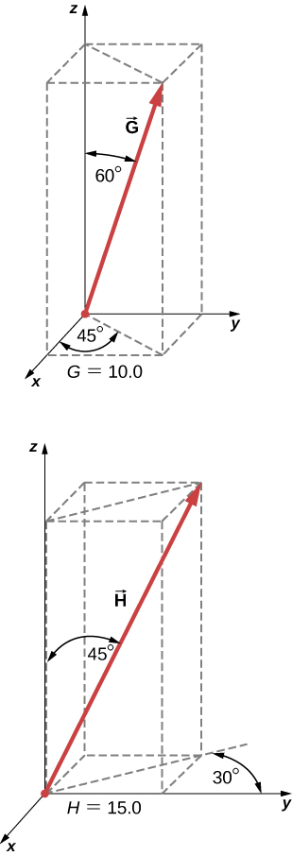

Solution

 

1. A diver explores a shallow reef off the coast of Belize. She initially swims 90.0 m north, makes a turn to the east and continues for 200.0 m, then follows a big grouper for 80.0 m in the direction  north of east. In the meantime, a local current displaces her by 150.0 m south. Assuming the current is no longer present, in what direction and how far should she now swim to come back to the point where she started?

Solution

270 m,  north of west

1. A force vector  has *x*- and *y*-components, respectively, of –8.80 units of force and 15.00 units of force. The *x*- and *y*-components of force vector  are, respectively, 13.20 units of force and –6.60 units of force. Find the components of force vector  that satisfies the vector equation 

Solution



1. Vectors  and  are two orthogonal vectors in the *xy*-plane and they have identical magnitudes. If  find

Solution

 or 

1. For the three-dimensional vectors in the following figure, find (a)  (b)  and (c) 



Solution

a. , b. 76.60, c. 1.024

1. Show that  is the volume of the parallelepiped, with edges formed by the three vectors in the following figure.

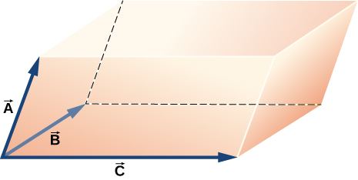

Solution

proof

**Challenge Problems**

1. Vector  is 5.0 cm long and vector  is 4.0 cm long. Find the angle between these two vectors when  or 

Solution



1. What is the component of the force vector  along the force vector 

Solution



1. The following figure shows a triangle formed by the three vectors   and  If vector  is drawn between the midpoints of vectors  and  show that 

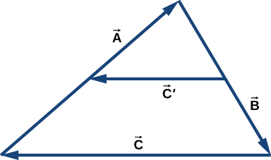

Solution

proof

1. Distances between points in a plane do not change when a coordinate system is rotated. In other words, the magnitude of a vector is *invariant* under rotations of the coordinate system. Suppose a coordinate system S is rotated about its origin by angle  to become a new coordinate system  as shown in the following figure. A point in a plane has coordinates (*x*, *y*) in S and coordinates  in 
2. Show that, during the transformation of rotation, the coordinates in  are expressed in terms of the coordinates in S by the following relations:



1. Show that the distance of point *P* to the origin is invariant under rotations of the coordinate system. Here, you have to show that



1. Show that the distance between points *P* and *Q* is invariant under rotations of the coordinate system. Here, you have to show that



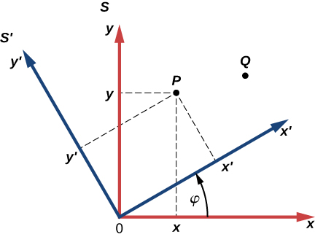

Solution

proof

This file is copyright 2016, Rice University. All Rights Reserved.